* Log on to <http://isuportal.indstate.edu>
* On the Homepage, click on My Banner Self Service
* Click on Employee
* Click on Leave Report
* Click on Proxy Set Up

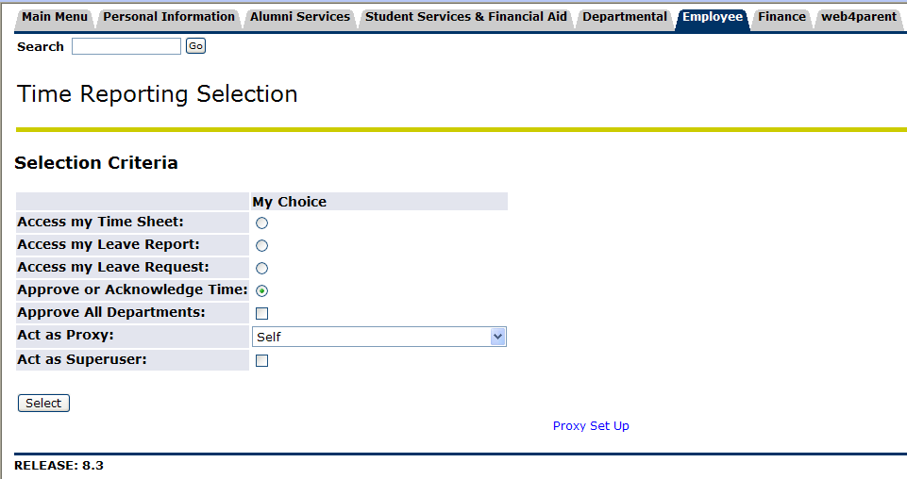

A list of names will come up in alphabetical order. The only people who are defined as valid proxies, must have a Banner user id and added to the selection form (goaeacc) in Banner by Payroll.

Click the **Add Remove** square and **Save**.

Important Information about Proxies:

* Proxies should be defined and reported to Payroll via the Authorization Form (available on <http://web.indstate.edu/payroll/leavereporting.htm>)
* Every Approver should have one and only one Proxy. This Proxy will act in the Approvers absence.
* If the Approver does not have a Proxy, an error will come up on the 6th of the month report where the Proxy name is listed.
* Payroll will conduct regular audits to assure all Approvers do indeed have a Proxy. If this is not the case, the Approver will be notified.