1. Search for the item in the library.

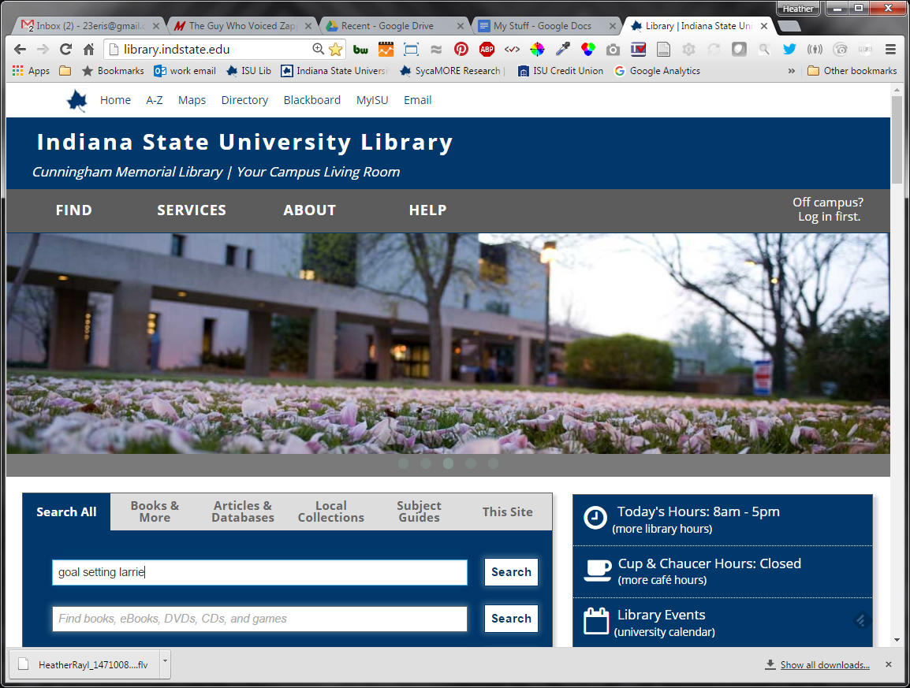

1. Click on “Full text online” in SycaMORE Research.”

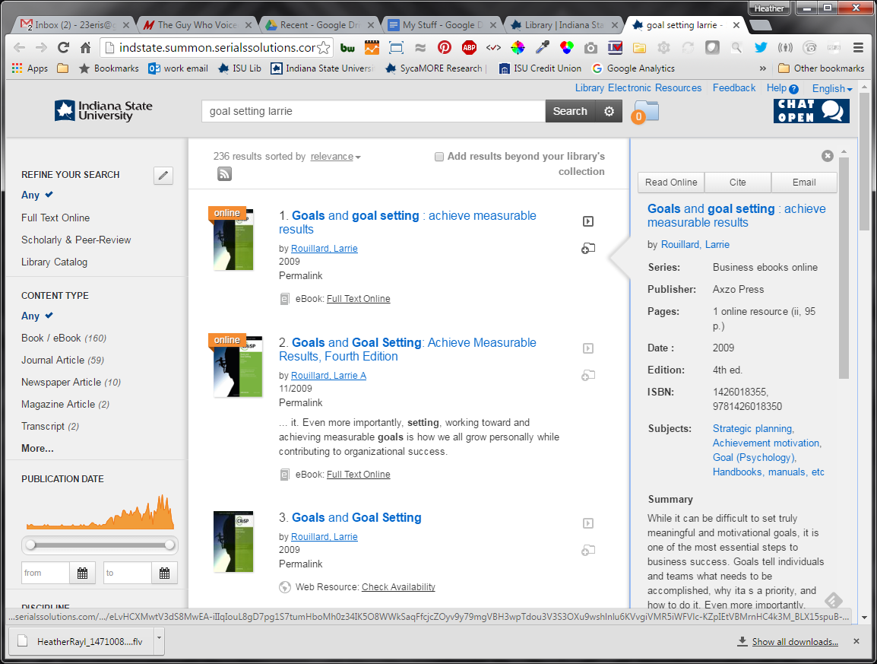

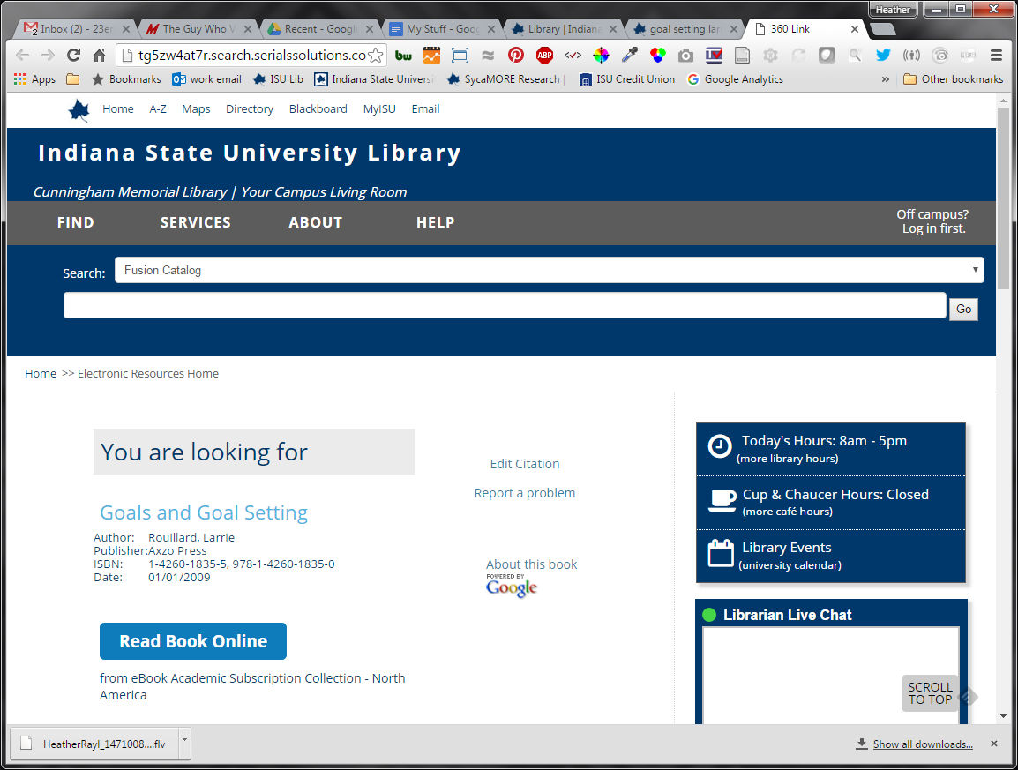

1. Click on “Read Book Online” button.
2. Click on permalink in the right hand column, and copy the link in the permalink box that appears above the title.

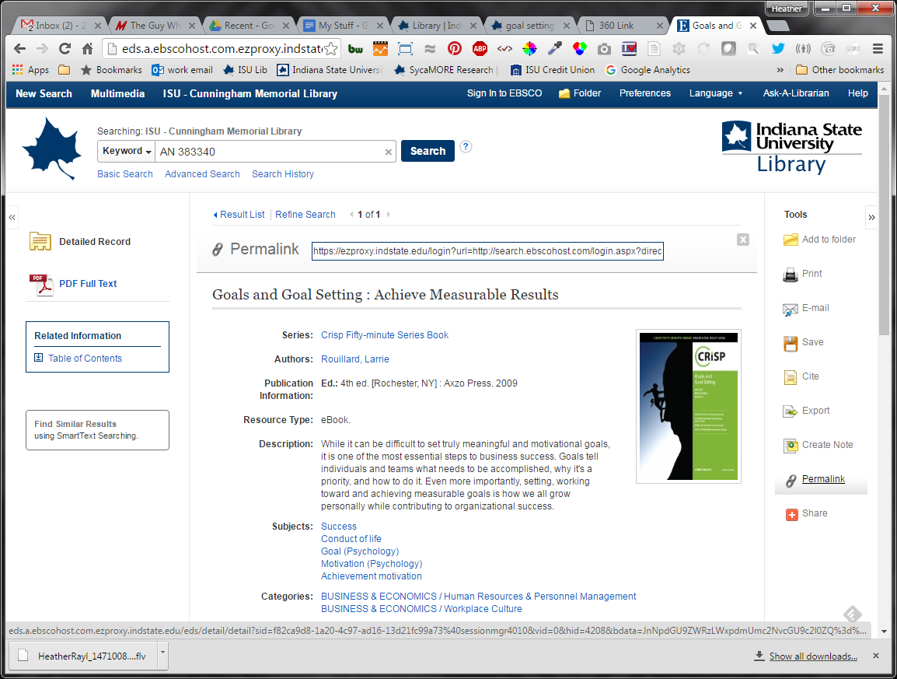

Linking to a Book Part

1. If you want to link to a particular chapter of the book, first, find the chapter you want to link to in the table of contents. (scroll down the page to see it)

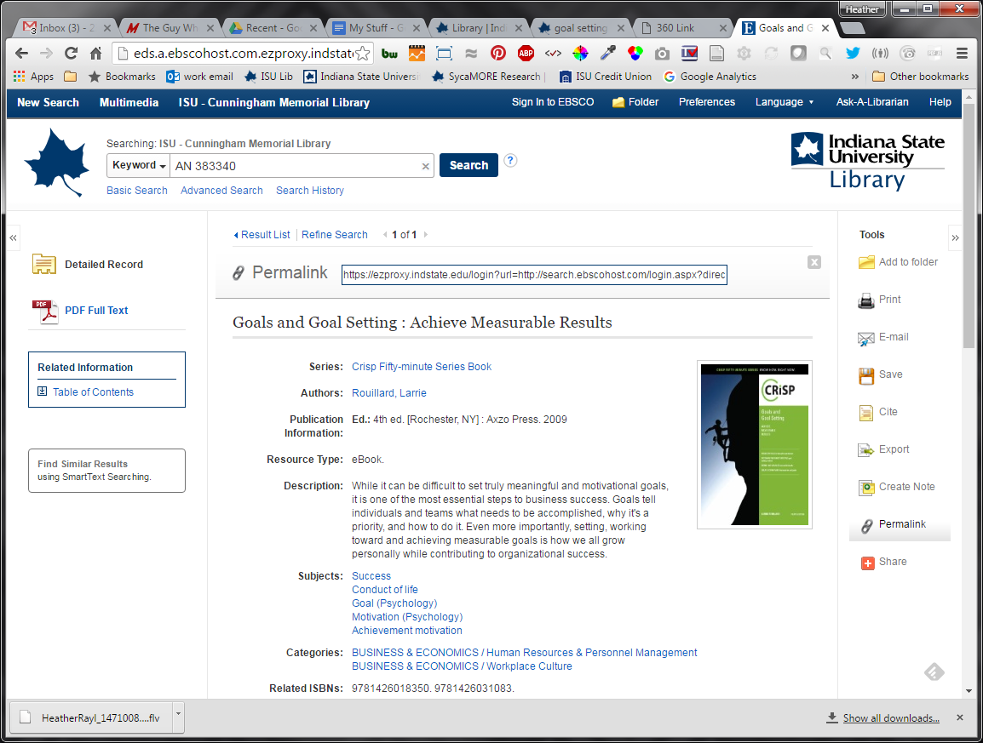

Scroll down until you find the TOC

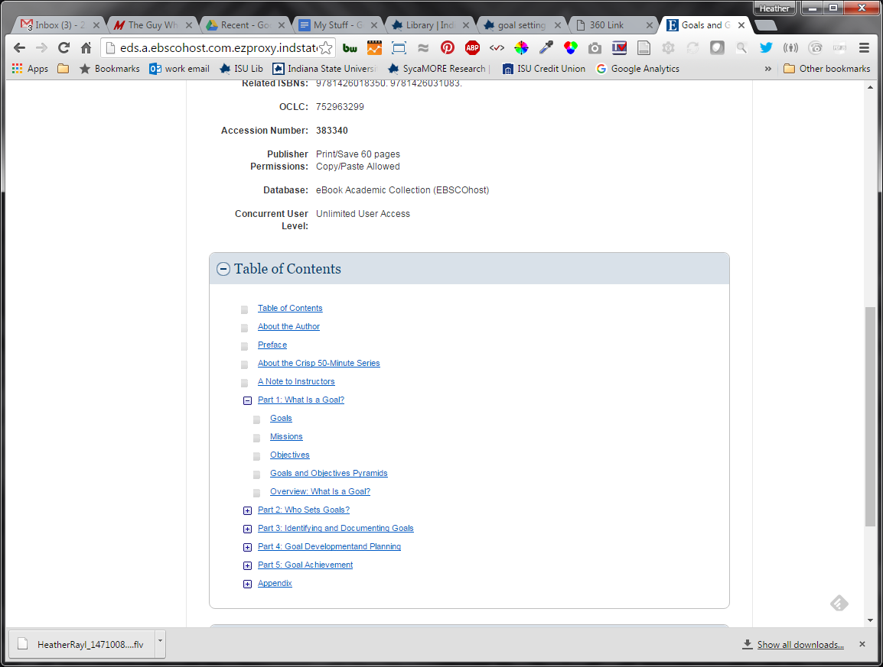

1. Along the top, you will find option of what to do with the document. You might see “Permalink” up there if your screen is wide enough. If not, click the three dots, and then choose permalink.

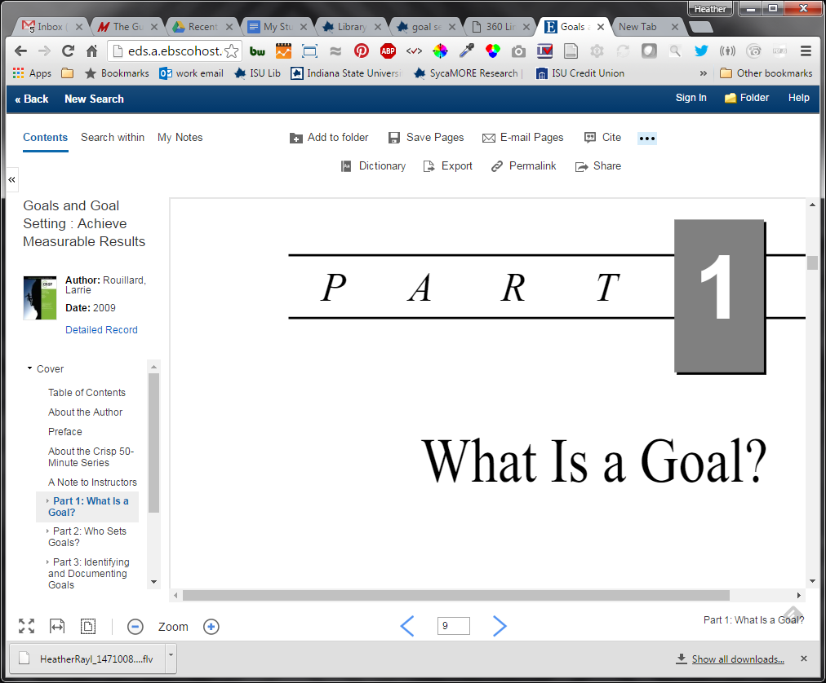

If you don’t initially see permalink in the list, click the three dots to expand the menu options.

1. Copy the URL that appears in the Permalink Box. This will take you directly to this part of the book.

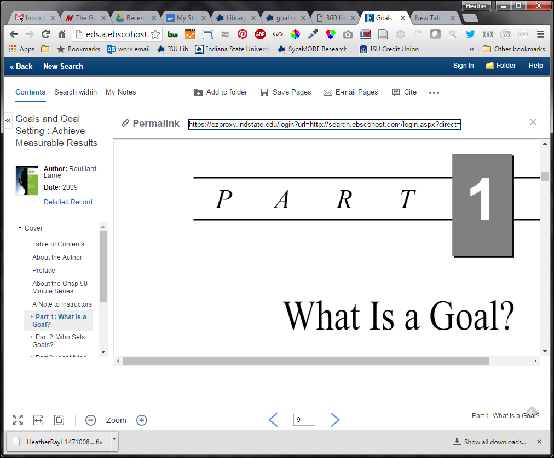

NOTE: NEVER use the URL that appears in the browser bar!!!

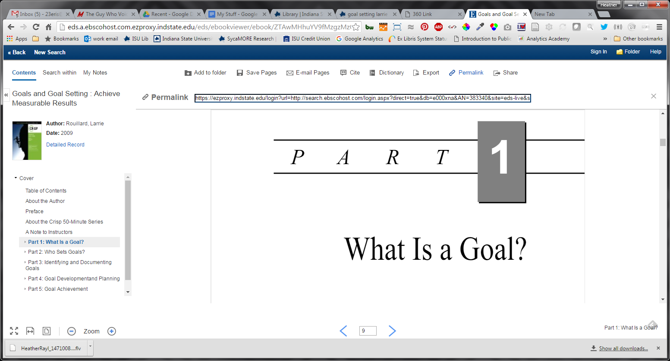

DO NOT USE THIS LINK!