ALTOUR
Website by CONCUR

Indiana State University’s preferred travel agency is Altour Travel. An agent can assist you with making your airline reservations by calling 800-428-6186 or you can use their online booking system, CONCUR. Both methods of booking will be directly billed to ISU.
You can set up access to CONCUR for airfare through the Direct Billing section of the Travel website , or by clicking here.
If this is your first time accessing this site you will need to enter your ISU email address (no alias) in the User Name field and then use welcome1 as the password. You will then need to set up your profile and ‘Change Password.’ Once you have set up your password, click on the Travel tab:

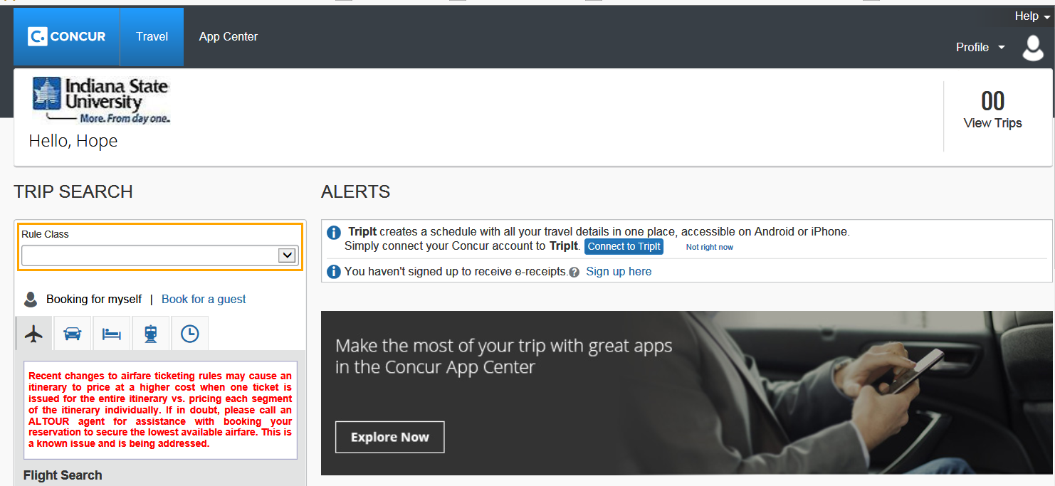

And then click on Recorded tutorials for Concur Travel/Expense/Mobile:
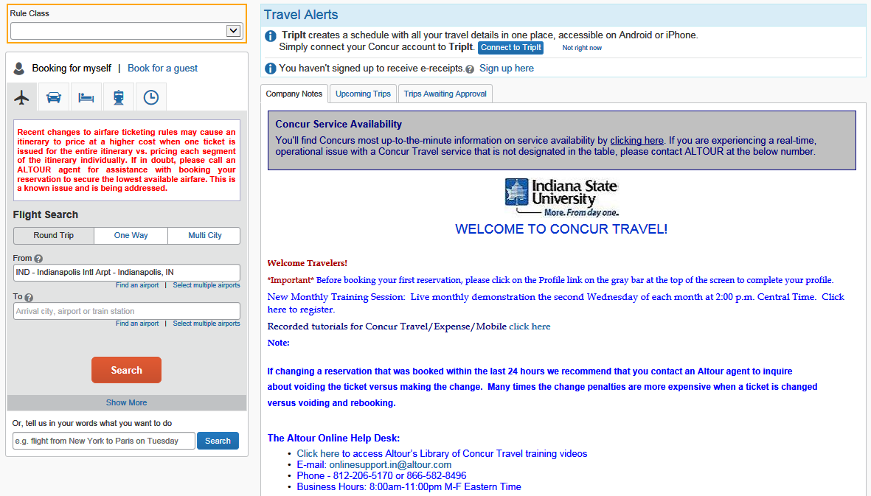

This will take you to online tutorial videos, quick reference guides, etc:
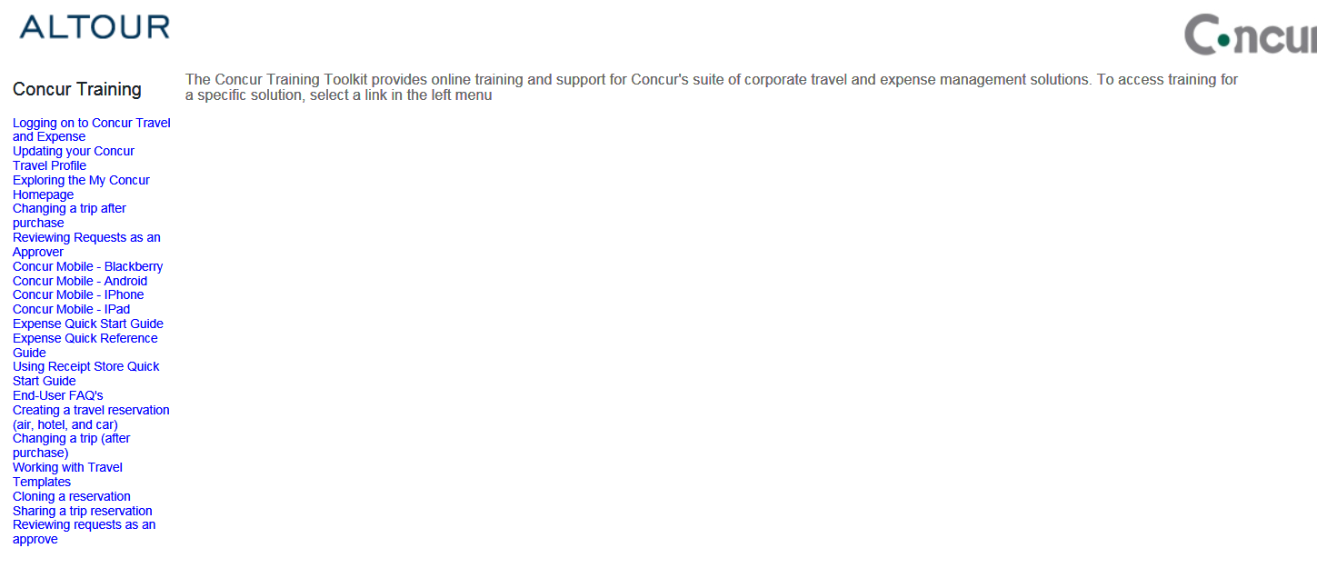

To add or make changes to your personal information, password, etc., choose the Profile option:

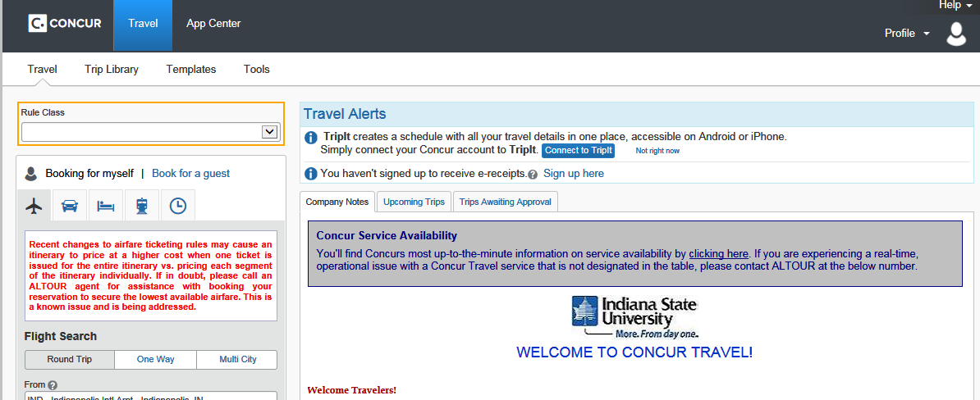

Fees:

Online Booking Fee: $10

Full Service Booking Fee (via phone): $29.00 Additional $10.00 if after
Regular business hours. Regular business hours end at 5:00pm EST
(Agents still available to assist after hours)

Car Rental and Lodging:
You may also choose to utilize their program to book your car rental and hotel needs, however, you will need to use a personal credit card as they cannot be direct billed to ISU. In order to avoid out of pocket expense you must book your rental cars through Enterprise Car Rental, and for Hotels.com for lodging.

