**Finance Self Service**

**Invoice Documents Approval**

The Approve Documents page allows you to approve or disapprove an invoice received by the Banner Finance approvals system.

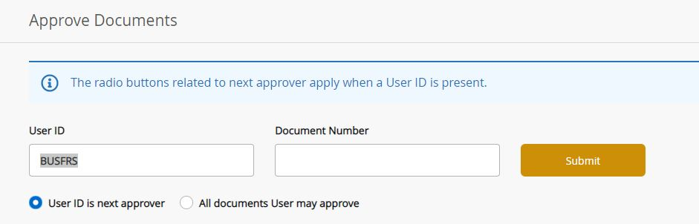

Click submit to bring up the list of documents to approve, enter a Banner document number in the Document Number box to bring up a specific document or use a wild card (%) to search for a document type. (Example: for all invoices in your que enter I% in the Document Number box).

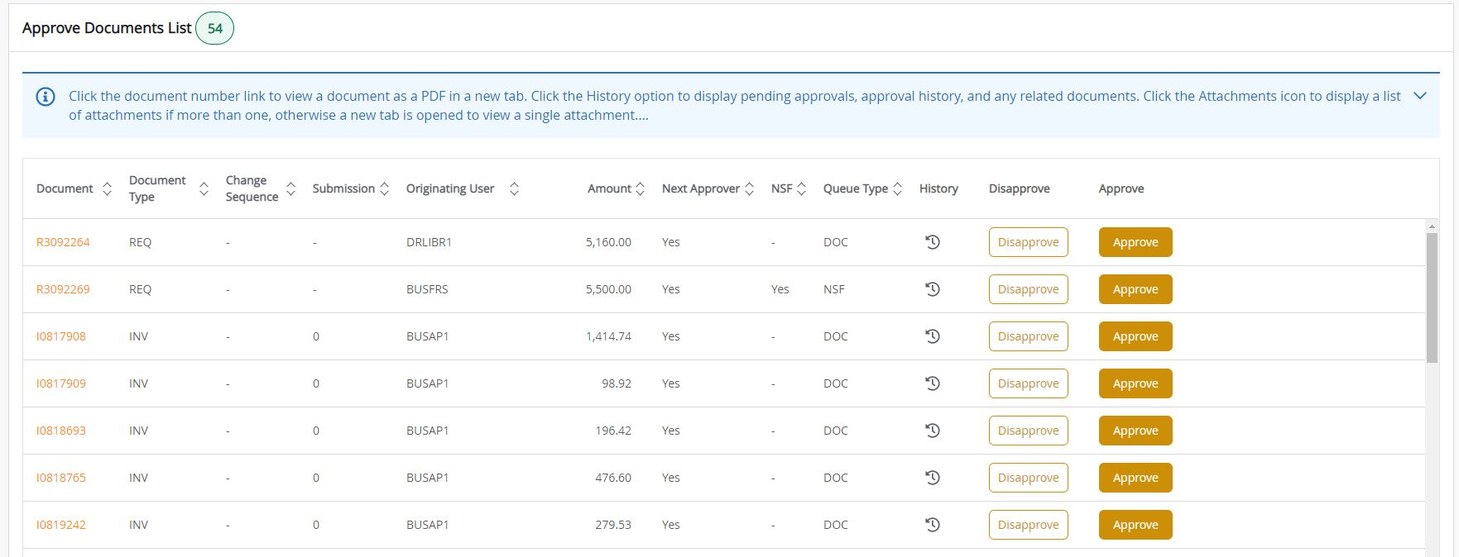

**Approve a document**

The **Approve** button enables an authorized user to approve the document.

The **Approve** button is only enabled if the person who logged in is authorized to approve the document.

1. In the **Approve Documents** list, review the document detail and supporting information related to a document.
2. Click **Approve**.

**Result:** The **Approve Document** window appears with the **Approve** and the **Cancel** buttons.

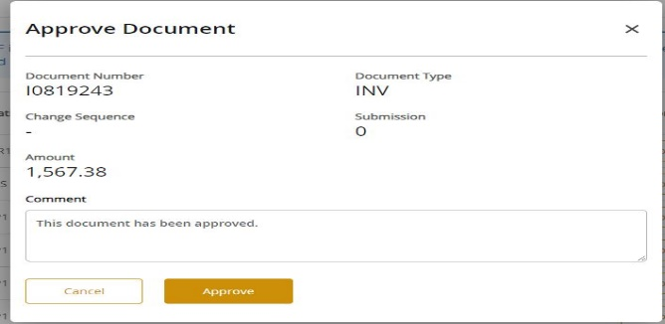

**Optional:** Enter a comment that explains the reason for approving the document. This goes through the Banner messaging system and the default approval comment can be edited or removed.

1. Click **Approve** to complete the approval process.

4. Click **Cancel** if you need to return from the **Approve Document** window without approving.

**Disapprove a document**

The **Disapprove** button enables a user to disapprove the document.

The **Disapprove** button is only enabled if the person who logged in is either authorized to disapprove the document or is the originator of the document.

1. In the **Approve Documents** list, review the document detail and supporting information related to a document.

2. Click **Disapprove**.

**Result:** The **Disapprove Document** window appears with the **Disapprove** and the **Cancel** buttons.



3. **Required:** Enter a comment that explains the reason for disapproving the document. This goes through the Banner messaging system and is a mandatory field.

1. Click **Disapprove** to complete the disapproval process.
2. Click **Cancel** if you need to return from the **Disapprove Document** window without disapproving.