How to Tell if a Requisition Has Been Disapproved

Once a user has entered a requisition into Banner it electronically goes to the Controller’s Office for approval. Sometimes some portion of the requisition will need to be corrected. When that happens the Controller’s Office staff will disapprove the requisition. It then becomes open for the department to make the corrections. How does the department know when that happens?

1. **Check Banner Messages**

On the Banner home screen locate the person icon on the toolbar on the left.



If there is a number over the icon that indicates how many messages there are to view. Click on the person icon and then select Check Banner Messages.

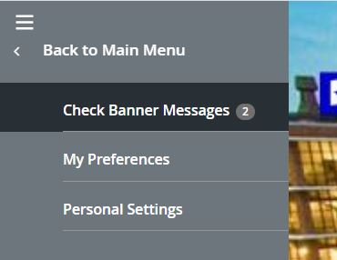

1. **GUAMESG screen**

The message screen will tell the department user what document has been disapproved (Item) and what needs to be corrected on the document (Message). If you cannot view the entire message click on the Comments icon at the end of the message line.



This will bring up a message box where the entire message can be viewed.

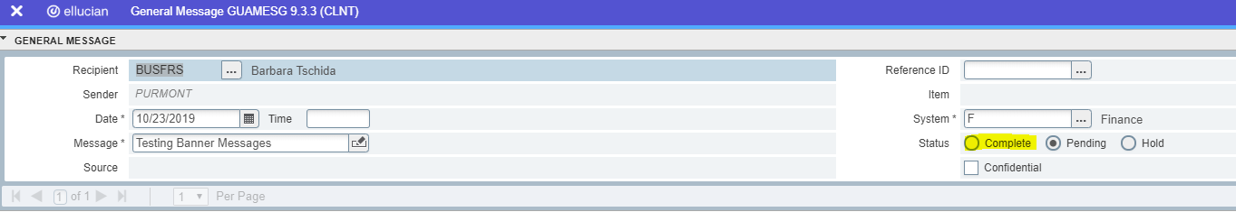

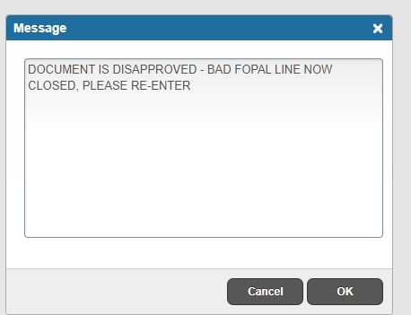

There could be multiple messages in this screen. Look at the navigation bar to determine if there is more than one message.

 Use the arrows to move to the next message.

Follow the instructions to correct the document that has been returned in Banner. Once the document has been updated and completed, return to the GUAMESG screen to delete the message. To do this, click on the Complete button under status and click save. The message will then be removed from Banner.