How to Find out if There is a W-9 on File
Go to the FTMVEND page.
If you know the Vendor ID, enter the ID in the Vendor field and click GO.
Click on the Additional Information tab.
Look in the More Details section on the bottom left on the page. If there is a number in the SSN/SIN/TIN box and a status of either 91 or 78 in the Tax Form Status box. Then the Controller’s office has a W-9 on file for this vendor.
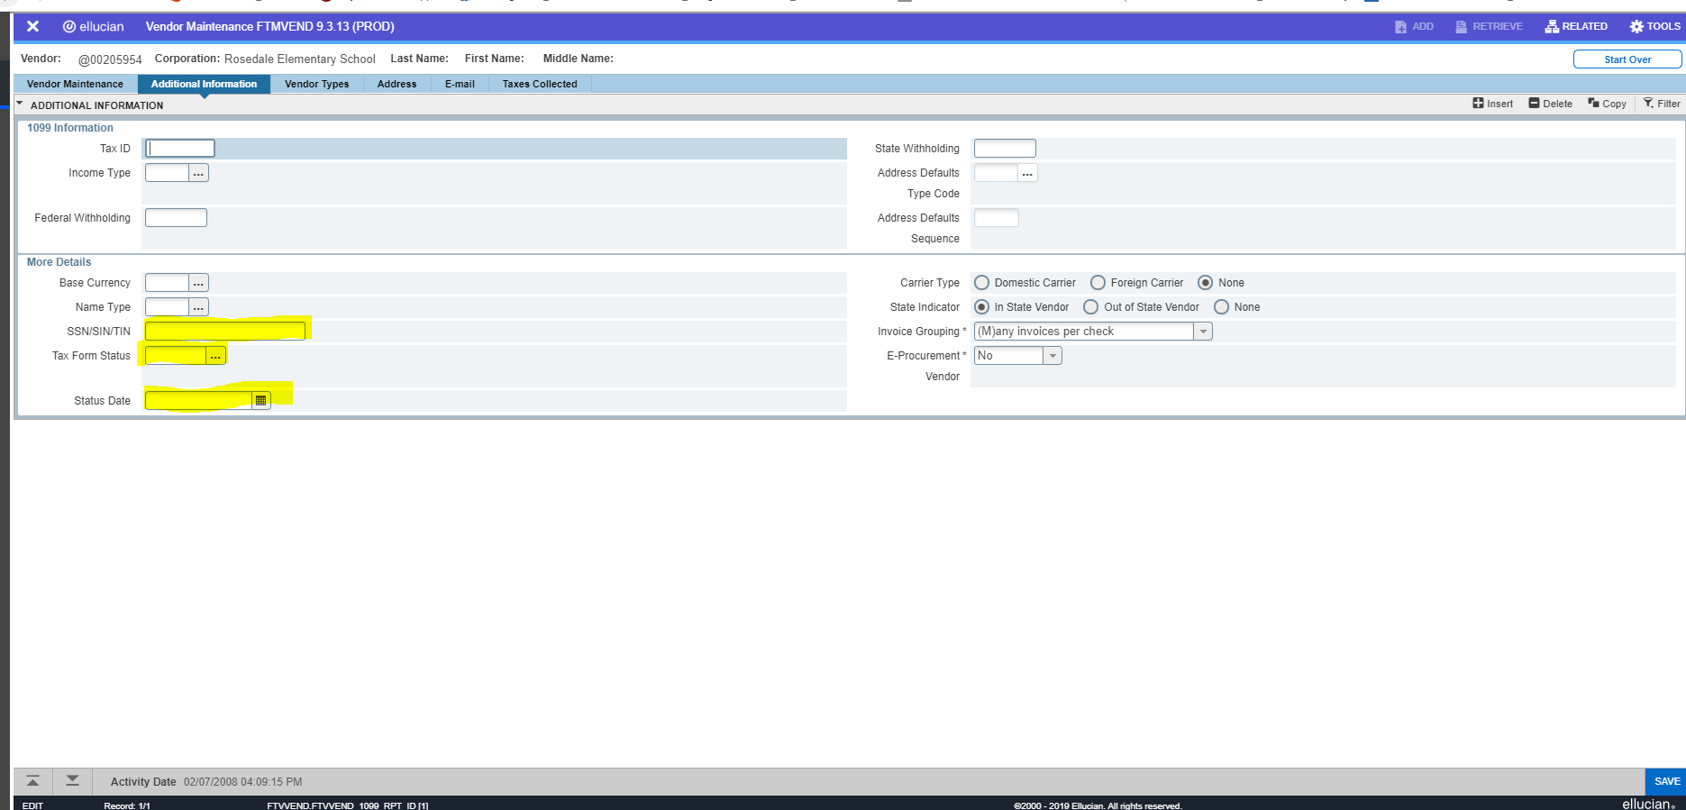

If you do not know the vendor number you will have to do a search for the vendor.
Click on the ellipses at the end of the vendor box.

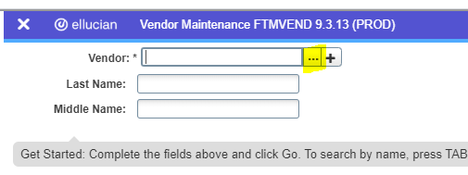
This will bring you to a search page (FTIIDEN). For a business, always use Last Name for your search. For a person you can use a combination of Last Name and First Name. A % can be used as a wild card in any part of the search name.

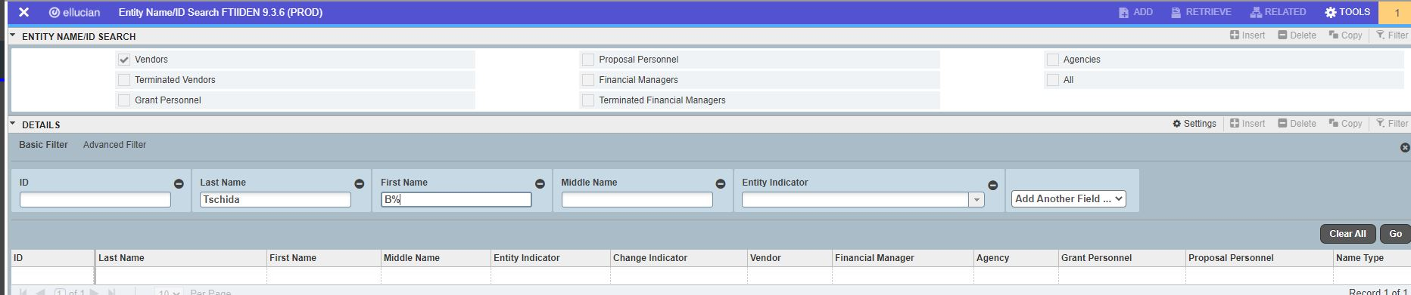

Once the search criteria is entered, select GO in the filter box. Any name that matches what you have entered will be brought up.
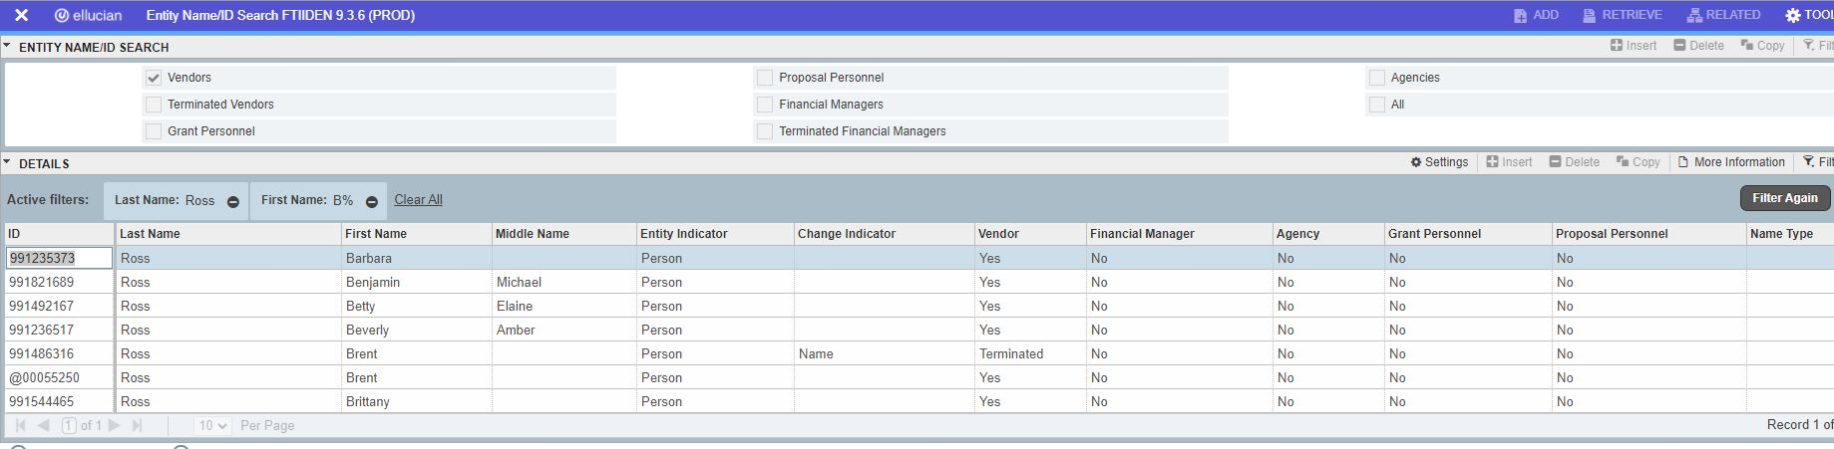
Once you find the desired vendor, click on it, so that it is highlighted and then click ‘Select’ at the bottom right of the page, or you can double click on the highlighted vendor. This will bring up the vendor on FTMVEND. Select Go to see the vendor information.
