How Do I View Travel Information on Banner?

**FGIOENC** – Shows all open encumbrances, encumbrance number, vendor/traveler, account code and amount encumbered.

1. Enter **Index**, then tab

2. Select **GO**

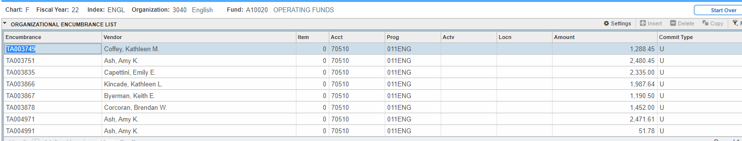

**FGIENCD**- Must know a Banner document encumbrance number. This shows the traveler, date established, index, account, and any transactions that have occurred on the TA in Banner.

1. Enter the Travel Authorization number in the **Encumbrance** box
2. Select **GO**

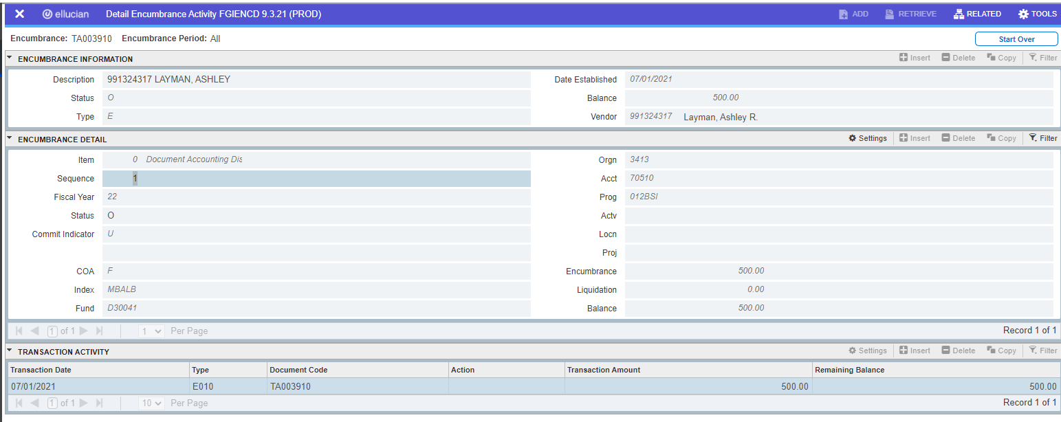

**FOATEXT**- Show Travel dates and brief description of trip

1. Enter Type: ENC

2. Code: Travel Authorization number

3. Select **GO**

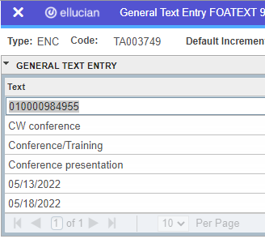

**FGIBDST- Budget screen**

Year to date activity for travel can be accessed by selecting a dollar amount for any travel account code in the YTD Activity column. Select Related, then Transaction Detail Activity -FGITRND

This will bring up any expense that has hit the selected index for the year in that account.

Encumbrance amounts and any changes to the encumbered amount will show up in the Commitments column. Select a dollar amount in the Commitments column and select Related then Transaction Detail Activity – FGITRND.