How to Approve an Invoice in Banner

The only time a user will have an invoice to approve is if they have entered a requisition into Banner. The requisition is turned into a purchase order, sent to the vendor, then accounts payable enters the invoice into Banner for the departmental user to approve.

When the user logs into Banner and enters a form name the Approval Notification Screen will pop-up.

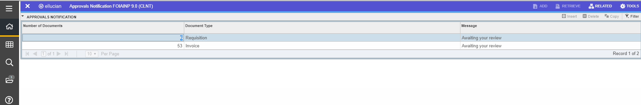

The user can either go to the approval screen by clicking on RELATED, at the top right of the screen, then User Approval (FOAUAPP). If they are already logged in they can type FOAUAPP in the search bar.

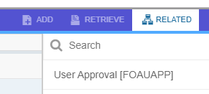

The approval form will have the user’s id prefilled.

Click on the GO button to view the invoices that are out there for them to approve.

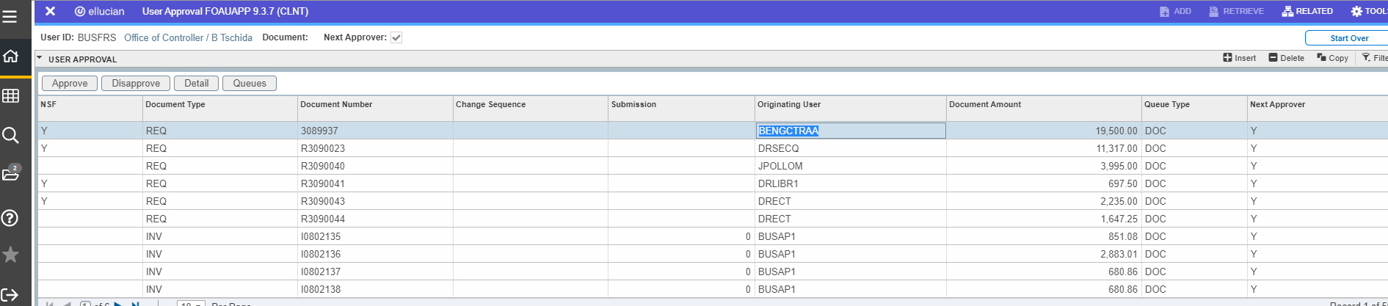

If the user needs to see the detail of that invoice they may click on the Detail button above the invoice list.
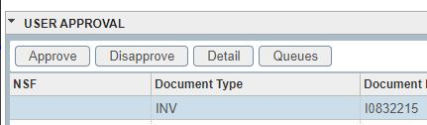
This will take them to the Invoice/Credit memo Approval screen (FOQINVA). There the user can view the vendor name, the index, account information and the amount.
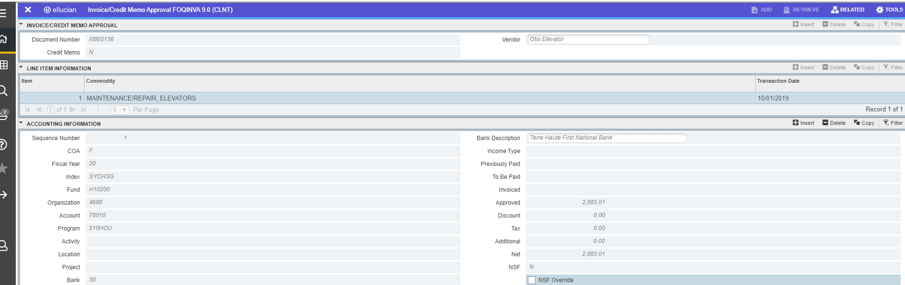

If more information is needed the user will have to click on the RELATED link (top right of the screen) and go to Query Document (FAIINVE). Use the navigation arrows at the bottom of the page to move through the invoice form (FAIINVE). On the commodity information page, under RELATED the Purchase Order Item text can be viewed. When the user is on Procurement Text Entry (FOAPOXT) they will have to select the GO button to view the available text. (The user will then have to navigate back to the approval page (FOUAUPP) by using the X’s in the top left corner of the page.)

Once back on the approval page the user can click the APPROVE button if the invoice is ready to be paid. Upon click the Approve button a second window will appear verifying that the user does want to approve the invoice for payment. Click ok at the bottom of the window to continue.

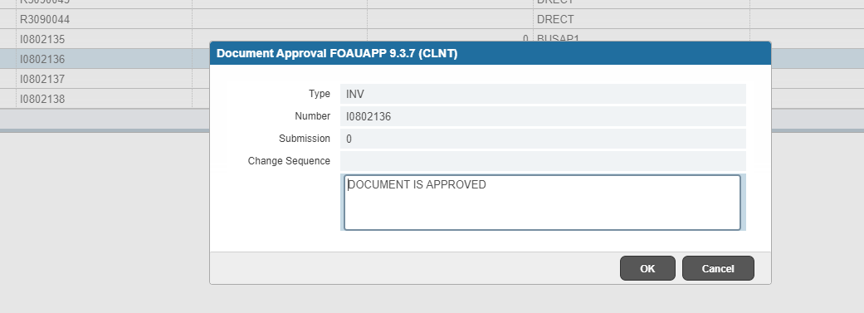

Click OK and you have successfully approved the invoice. The user will see the message in the right-hand corner in green that the document has your approval and was saved successfully. Click the number to remove messages.
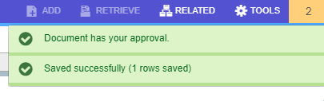
To disapprove a document, click on the Disapprove button. The Document Disapproval Text entry box will appear. Click in the box after the words ‘Document is Disapproved’ and enter the reason that the invoice is being disapproved by the department user.
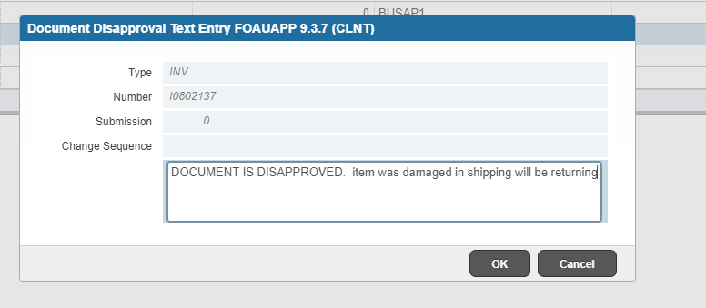

Again, the user will see a message in green in the upper right-hand corner.
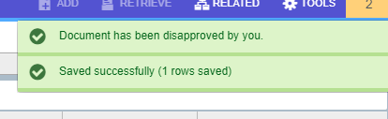

Use the X in the upper left-hand corner to close the approval page.

