How to Pull all Monthly Transactions Report From Banner for an Index

1. Go to **FGIBDST (Organizational Budget Status)**
2. Enter **Index**, hit tab, then select **GO**
3. Click on any dollar amount in the **YTD Activity Column**, then go to **Related**, top right corner and select **Transaction Detail (FGITRND)**
4. Once the transaction details come up click on **Start Over** in the top right-hand corner.
5. Delete **Account Number**
6. Click on **GO**
7. Close grey filter box with the tiny X in the top right-hand corner of the grey area

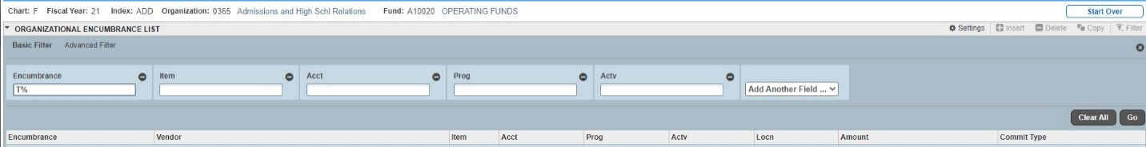

This brings up **every** transaction for the current fiscal year for that index.

You can export this into excel by selecting **Tools** (top right-hand corner ) then select **Export.**

**To get the activity for one month Click on the Filter**

This appears under the **Start Over** button**.**

Select **Advanced Filter.**

Select **Transaction Date** between first day of month and the last day of month.

Hit **GO** button in the filter box.

This will bring up the transactions that happened in the month that you selected.

You can export this into Excel by selecting **Tools** and **Export.**