My Finance Query

**My Finance Query overview**

My Finance Query allows you to query and view your Finance budget data.

You can use this application for the following:

• Create a query to retrieve Finance budget data

• Edit a query

• Share a query with others in your organization having the same level of access

• Delete a query

• Mark a query as a favorite

• Perform comparison queries

• Add computed columns to queries

• Download query results to Excel

• View Document.

• View related documents

• View approval history

The **My Finance Query** page lists your budget query history. Use this page to create budget queries and review budget queries you have designated as favorites, saved, or shared with others.

You can also use the **Search Query** field to search for queries by supplying the full/partial name of the query. The Search Query feature can also be used in combination with the Filter functionality. This feature works on all the three tabs in the dashboard – Favorite Queries, Saved Queries, and Shared Queries.

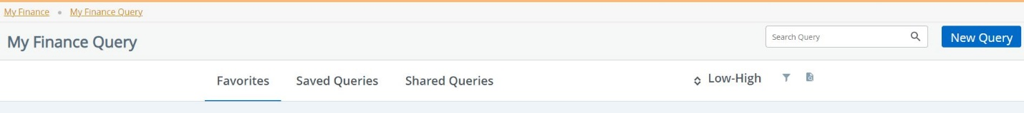

1. Favorite Queries - Queries previously saved as ones you typically view often.

2. Saved Queries - Queries saved for future viewing.

3. Shared Queries - Queries designated as shared, allowing anyone in your organization who has the same level of access to see the query.



You can sort dollar amount on queries using the Low-High indicator. The allows you to filter specific types of queries.

The can be clicked to view a specific document.

1. Use the **Document Type** drop down field to select the appropriate document type.

2. Use the **Document Search** to look up a document.

-OR Type the document number directly into the **Document Number\*** field.

1. Click **View Document** to open the document as a PDF.

**Note:** You can use the **Approvals & Related Documents** option to view the approval information and related documents.

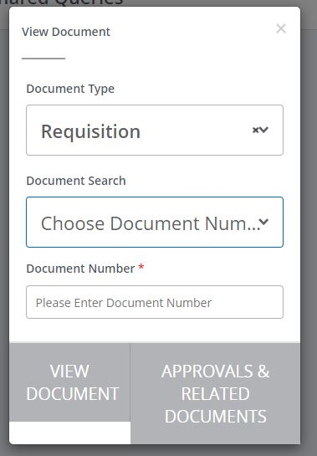

**Create a query**

You can create the following types of budget queries:

**Query Type Description**

1. **Budget Status by Account** - Budget information by accounts for the Fiscal Period, Year, and

Commitment Type (all, committed, or uncommitted) by the following:

• FOAPAL/Index values

• Single Organization

• Fund Type

• Account Type

• Revenue Accounts

• Wild-card (%) filters supported for FOAPAL

Wild card (%) can be used to search for unknown items. For example if you did not know the complete index but knew is started with ST, you could search ST% to bring up any index starting with ST.

1. **Budget Status by Organizational Hierarchy** - Budget information for organizations by the following:

• Hierarchical structure

• Specific Funds, high-level Organizations, Accounts, and Programs

• Fund Type

• Account Type

• Revenue Accounts

• Wild-card filters supported for FOAPAL

1. **Budget Quick Query** - Current budget status and displays information similar to that available on the Organization Budget Status (FGIBDST) page. When you choose this option, be aware of

the following:

• Only one parameter page displays for this query. Ledger fields displayed include **Adjusted**

**Balance**, **Year to Date**, **Net** **Commitments**, and **Available Balance**.

• Wild-card filters supported for FOAPAL.

• You can enter the fiscal year. Data displayed will be through period 14.

Banner period 14 is every transaction Year to Date since the last time posting ran.

Banner periods are as follows: 1-July, 2-August, 3-September, 4-October, 5-November,

6-December, 7-January, 8-February, 9-March, 10-April, 11-May, 12-June, 14-YTD

1. **Encumbrance Query** - Budget information by encumbrance information for the Commitment

Type (all, committed, or uncommitted), Encumbrance Status, and Fiscal Year and Period.

1. **Multi Year Query** - New Query type to support the current budget status by Grant which

displays information similar to that available on the Grant Inception to Date (FRIGITD) in the

admin application. Wild-card filters supported for FOAPAL.

How to create a New Query:

1. On the **My Finance Query** page, click **New Query**.

2. On the **Create New Query** window, in the **Select Query Type** field, select the budget query type.

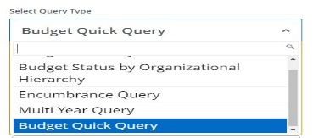

3. In the **Values** area, select the values and the Operating Ledger columns for which you want to query.

4. Click **SUBMIT**.

**Result:** The **My Finance Query** page appears with query results. Using the available icon

buttons, you can edit, share, save, view query parameters, add computed columns +, download results to Excel, or view available balance, pending documents, and payroll (if applicable).

Hints:

Red * means that a field must be selected to run query.

To clear fields: Select a populated box and click the X

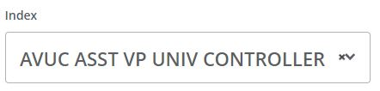

To search for an index: Select the down arrow (see above by the x) and start typing the index in the blank space or scroll through the index list. A list of possible indexes that match you search will appear. Select the desired index by clicking on it. It is possible that you will have to scroll down to see the index that you want.

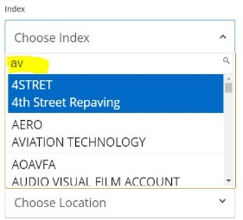

On Budget Status by Account

If you have used a high level search, click on Org or Org Title to drill further down.

Click on dollar figures to drill down to more data. Then select account type to drill further down. Use the < arrow on the page to go back up to the original level.

+ - add computed columns is only available on Budget Status by Organizational Hierarchy, Multi Year, Budget Status by Account

Under Saved Queries you can favorite, share or delete the saved query

**Save a query and mark it as a Favorite**



You can save a query and mark it as a favorite.

**Procedure**

1. Create a query that you want to save.

**Result:** The **My Finance Query** page appears with query results.

2. Click to access the **Save as** window.

3. Enter a query name in the provided field.

4. If you want to set the query as a Favorite, select the **Set as favorite** check box.

5. Click **Save**.

**Tip:** You can also use the icon of a query displayed in the card view to toggle a query between Favorite and Unfavorite.

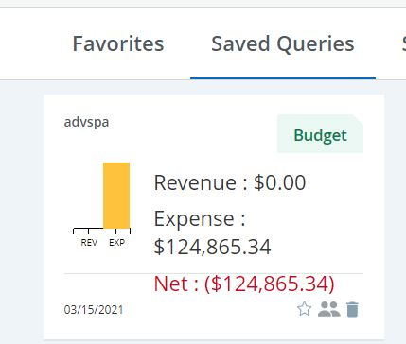

**Edit a query**



You can edit a query to adjust results.

**Procedure**

1. On the **My Finance Query** dashboard page, click the **Saved** or **Shared** query you want to edit.

**Result:**

• Clicking saved queries loads query results. Click to access the **Edit Query** window.

• Clicking a shared query in the query list accesses the **Edit Query** window.

2. Using the **Edit Query** window, adjust the selections for the query.

3. Click **SUBMIT**.

**Result:** The **My Finance Query** page appears with query results.

**Share a query**



Sharing a query allows anyone in your organization who has the same level of access to see the

query.

1. On the **My Finance Query** dashboard page, locate the query you want to share in the Favorites

or Saved areas.

1. Click 
2. The  icon which indicates that the query has been shared. Click the icon again to unshare.

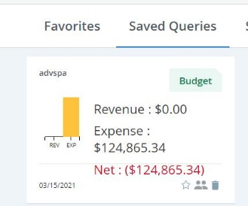

**Download a query to Excel**

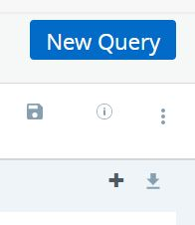

You can download a query as an Excel spreadsheet.

1. Create or view a query that you want to download.

2. Click  to download the query to the default download location on your local drive.

**Delete a query**

You can delete saved queries.

1. On the **My Finance Query** dashboard page, click **Saved Queries**.

2. Locate the saved query you want to delete and click.

3. On the delete prompt, choose the appropriate option.

**Add computed column**

You can add a computed column to query results.

**Note:** You can add a computed column to all query types except Budget Quick Query.

1. Create or view the query to which you want to add a computed column.

2. Click to access the **Computed Columns** window.

3. Define the computed column by naming it and selecting the two columns and the operator

controlling the new column's results.

4. Click **Compute**.

**Result:** Query results reload listing the new computed column in the results.

**What to do next**

**Tip:** You can use the **Remove** tab to remove a previously added computed column from a query.