How to View Purchase Orders on the Finance Dashboard

Finance has to grant access to the user to be able to view the Finance Dashboard. If you do not have access, please contact [Barbara.tschida@indstate.edu](mailto:Barbara.tschida@indstate.edu) to be granted permission to see the dashboard.

To get to the Finance Dashboard:

1. Select the Employee Self Service Badge
2. Select Finance Services
3. Select the Finance Dashboard

Once you are on the Finance Dashboard you will need to select the View Documents Icon. You will need to know a Banner Document Number.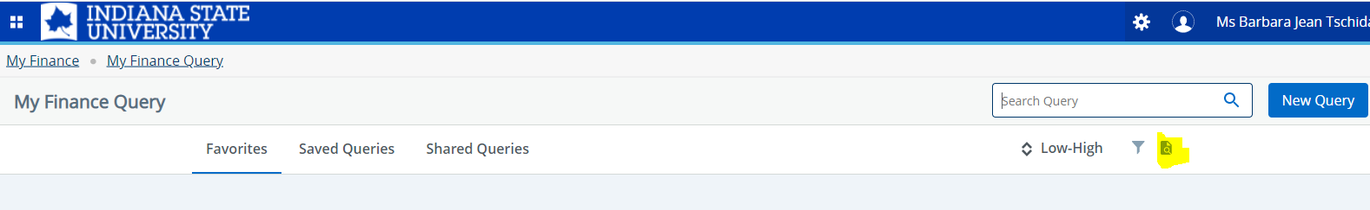

Once you click on the icon a View Document window will pop up.

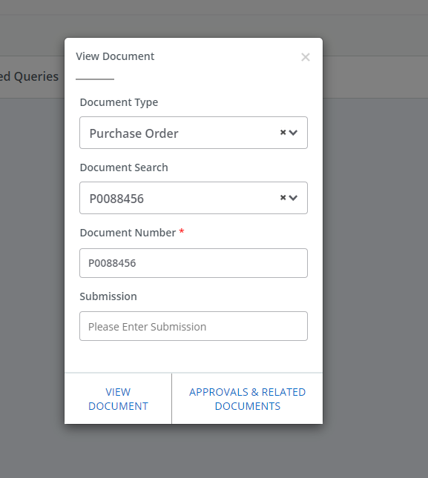

1. Select the type of document you want to view.
2. Under document search, start typing in the document that you want to view. Once that document number comes up, you must click on it to select it.
3. At the bottom of the small window select View Document.

This will bring the document up, it can then be printed or saved as a PDF>