**Indiana State University Scheduling Policies and Procedures**

**General Policy Regarding the Academic Scheduling Process:**

* The policy for class scheduling is established by the Office of the Provost and implemented by the Office of the Registrar.
* General objectives in building the Schedule of Classes include providing workable schedules for students by departments, ensuring access to courses by students, making efficient use of classrooms and laboratories/special laboratories, and minimizing overhead associated with Schedule of Classes administration.
* All classes are scheduled to start at the hour or half-hour.
* Departments/colleges will have the ability to schedule in rooms they manage first. After this, the Registrar's office will utilize all available classrooms to assist other departments in need of space. All departments involved in the optimization process will be notified by the Registrar's office.
* The primary goal of the Academic Scheduling Process is to maximize the probability that all students receive their choice of courses required for graduation on a timely basis (within the prescribed number of semesters) by providing a conflict-free resource environment (staff, space, and courses) which minimizes operating and capital costs.

The following are standard meeting times and patterns for classes for Fall and Spring:

* MWF is the normal sequence for classes meeting three days a week for 50 minutes, beginning on the hour.
* TR is the normal sequence for classes meeting two days a week for 75 minutes, beginning on the hour or half hour. Courses may meet MW, but will need to start after 2 pm.
* One day a week classes that meet for two or three hours must meet after 2 pm.
* Night classes meet after 4 pm.

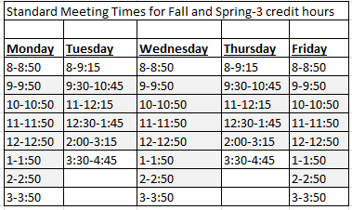

*Shading indicates Prime Time

**Contact Hours for Fall and Spring**

|  |  |  |  |  |
| --- | --- | --- | --- | --- |
| **Standard Times for 3 hour classes-16 week session** | | | | |
| **Days** | **Minutes per Class Meeting** | | **Total Meetings** | |
| 3 | 50 | | 48 | |
| 2 | 75 | | 32 | |
| 1 | 150 | | 16 | |
| **Standard Times for 3 hour classes-8 week session** | | | | |
| **Days** | | **Minutes per Class Meeting** | | **Total Meetings** |
| 3 | | 100 | | 24 |
| 2 | | 150 | | 16 |
| 1 | | 300 | | 8 |

**Contact Hours for Summer-effective Summer 2015**

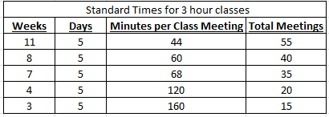

The amount of contact hours for a three credit hour course is 2400 minutes per session. Summer classes are required to start on the hour or half hour with the earliest starting at 7am. Non-Standard meeting patterns must be approved by Academic Affairs.

**Federal Credit Hour Definition**: A credit hour is an amount of work represented in intended learning outcomes and verified by evidence of student achievement that is an institutionally-established equivalency that reasonably approximates not less than:

(1) one hour of classroom or direct faculty instruction and a minimum of 2 hours of out-of-class student work each week for approximately fifteen weeks for one semester or trimester of credit, or ten to twelve weeks for one quarter hour of credit, or the equivalent amount of work over a different period of time; or (2) at least an equivalent amount of work as required in paragraph (1) of this definition for other activities as established by an institution, including laboratory work, internships, practica, studio work, and other academic work leading toward the award of credit hours.