IRB related guidelines

- Read Me First includes a full explanation of the process
- Guidance for Selecting Level of Review
- The Form A New Application Checklist & Instructions for Submitting, which includes the Form A and Informed Consent resource video: http://youtu.be/7L0Bijk2q4M
- Guidance for Qualtrics Security & Data Privacy
- Guidance for Preparing Informed Consent Materials
- What commonly slows down IRB Review (the Pre-Review)

We have provided a screenshot below with some markers to identify those materials.

Link: http://www.irbnet.org/

Step 1 : Click on the link
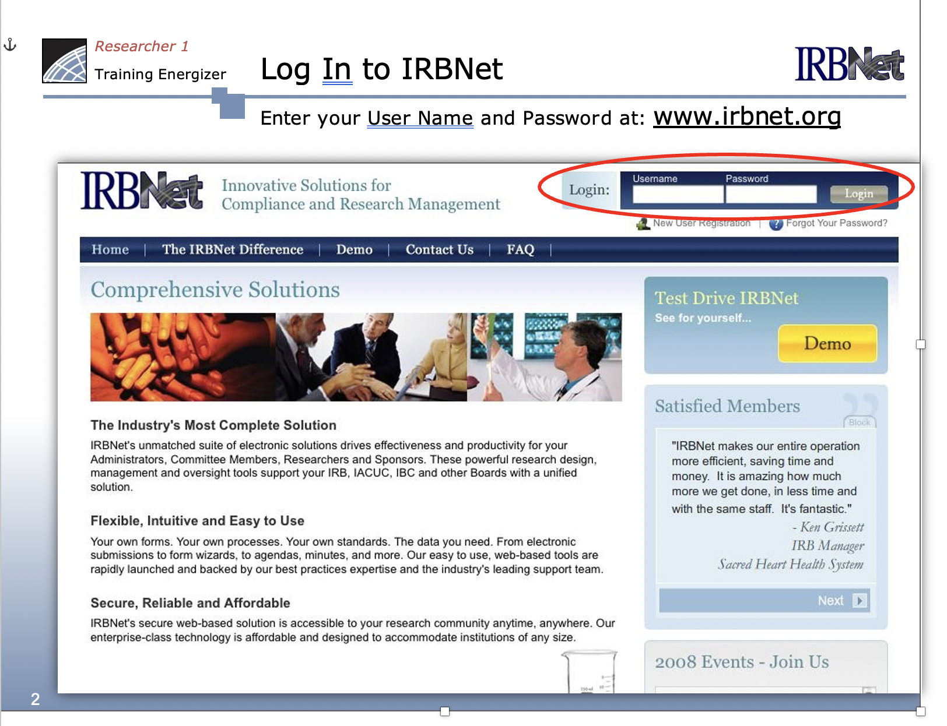

Step 2: Researchers should click the “Forms and Templates” tab under the “Other Tools” heading. Then they can “Select a Library” and choose the “IRB – Documents for Researchers.”

